**Guided Capstone Project Report** November 28, 2020

**Ticket Price Modeling for Big Mountain Resort** Walter Piper

What is the optimal ticket price for Big Mountain Resort, given its unique set of features and the price-associations of features at other resorts nationwide? What features could be increased to support a higher ticket price, and could anything be removed without undermining ticket price?

The current price is $81.00 for AdultWeekday and AdultWeekend. Although this is the most expensive in Montana (see figure for prices grouped by state), it is only in the 81st percentile nationwide for AdultWeekend and 85th percentile for AdultWeekday.

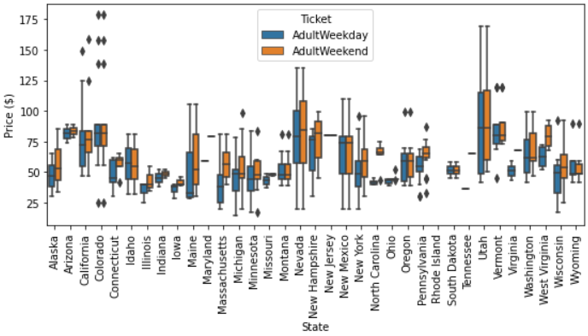

**Big Mountain**

We started with data from the file ‘ski_resort_data.csv’, containing 330 rows and 27 columns. The fastEight column was dropped because half the values were missing, and the AdultWeekday column was dropped in favor of modeling the AdultWeekend column as the model’s target variable. All rows not containing AdultWeekend price values were dropped, leaving a shape of 277 rows (including Big Mountain Resort) and 25 columns.

An auxiliary DataFrame containing state-level data was made to engineer additional features. State-level features and resort-features relative to state totals were then used to augment the original data set, leading to a total of 32 numeric features being used to predict price.

A random forest model (with 69 estimators) trained on 276 entries containing AdultWeekend ticket information revealed that Big Mountain Resort’s current ticket price is underestimating the true value.

The column plot figure below shows the relative importance of features for predicting ticket price. In order from most to least important, the most important features are fast quad chair lifts, total number of runs, snow-making acreage, vertical drop, skiable acreage, and total chair lifts.

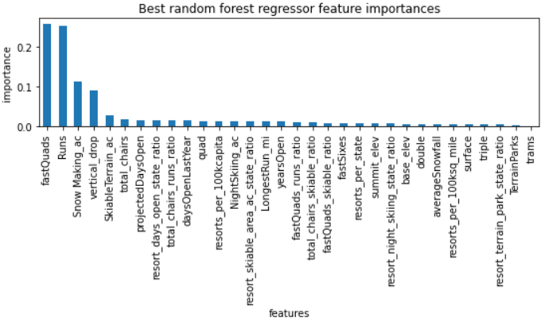

On the most important predictors of ticket price, Big Mountain Resort (large red dot) excels.

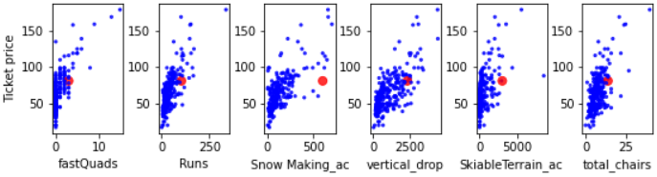

Considering the current features at Big Mountain Resort, **we recommend a ticket price of $95.87**, **with a range** **of $85.48 - $106.26** (+/- mean absolute error; MAE).

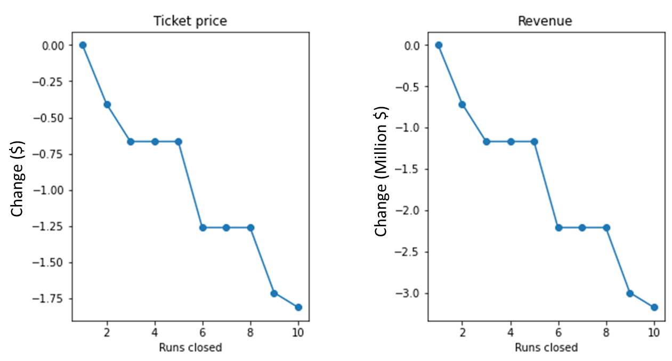In addition, we tested the 4 feature alteration scenarios that were short-listed by the Big Mountain Resort team:

1. Close between 1 and 10 runs
   1. 🡪 **Closing a single run would not change the price suggestion** but closing 2 or more would reduce the ticket price by an average of -$0.18 per run closed (shown in line plot on right).
2. **Extend vertical drop by 150 feet, and add a run and chair lift** 
   1. **🡪 This would increase the price suggestion by $1.99 per ticket.**
3. Extend vertical drop by 150 feet, add a run and chair lift, and add 2 acres snow-making.
   1. 🡪 This would increase the price suggestion by $1.99 per ticket. No added benefit over scenario 2.
4. Increase longest run by 0.2 miles and add 4 acres snow-making.
   1. 🡪 No gain.